# A notepad with blue writing Description automatically generatedInitial Ideas

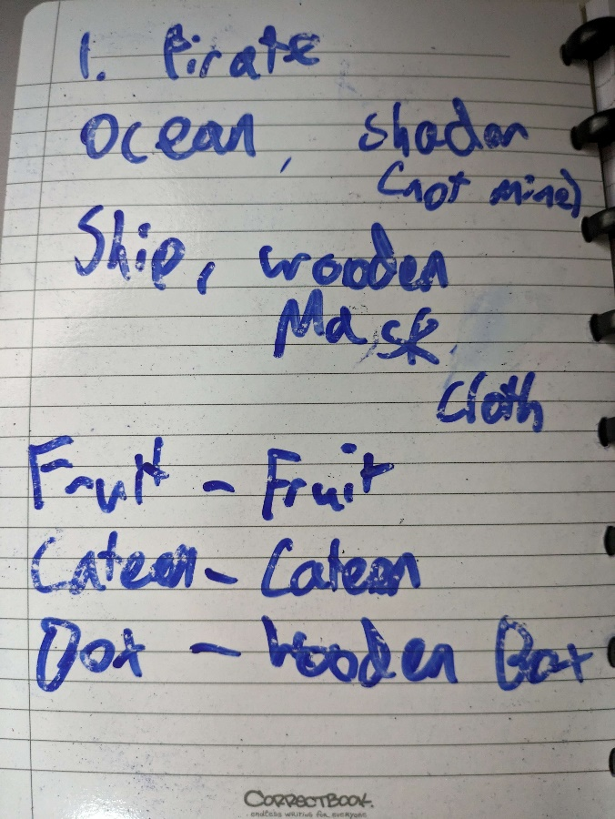

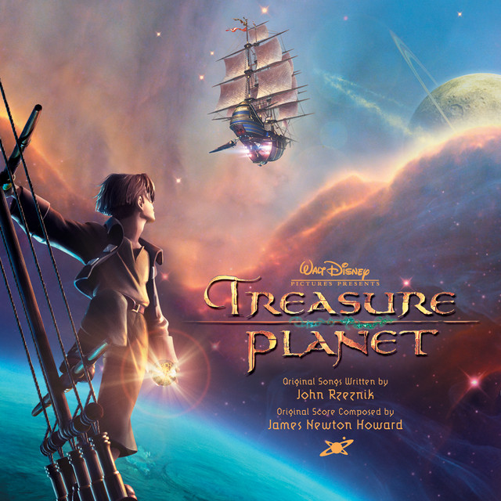My first idea was to go for the classic pirate theme and make a quite generic pirate game with a bigger focus on **VR** interactivity, but the game quickly converted into a more **sci-fi based theme** being inspired by D*isney’s Treasure Planet*.

After some quick brainstorming I quickly resolved on the idea of a broken **animatronic** from a ***Disney ride*** who had become **sentient** and made it to **space**. From here it had created a scrap version of the pirate ship from their show and now roams around an asteroid system trying to survive from scraps.

The survival gameplay here being that the **robot** could be old and requires a **high amount of oil intake** and the player must constantly be **scavenging** for more oil around their star system creating it from matter around itself.

# Planning Theme – Sci-Fi

## Environment

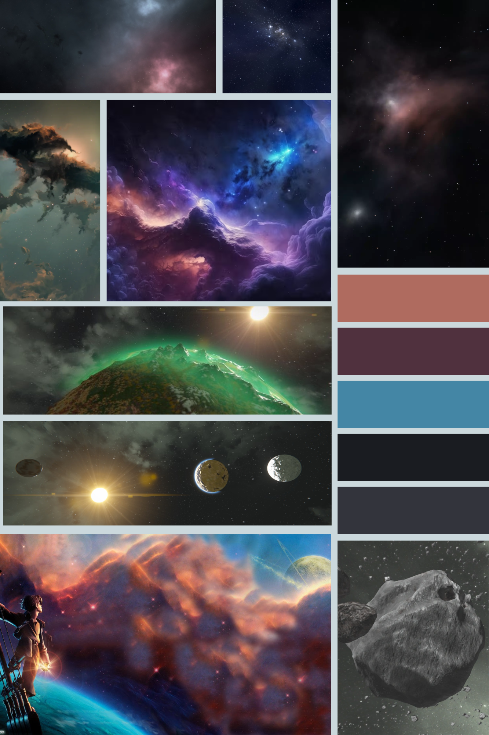

## Ship

For the ship I envision a pirate ship made of entirely scrap metal, bolted rusted parts from other crashed ships (maybe from an asteroid belt) combined to make what looks like an old timey pirate ship.

Ideally something would already exist for this specific idea that I could import straight into unity but searching around for “Spaceship” or “Sci-Fi Pirate Ship” yielded little results.

Although not a part of the brief I started to create some base prototypes for the ship to set the theme for the other items on it.

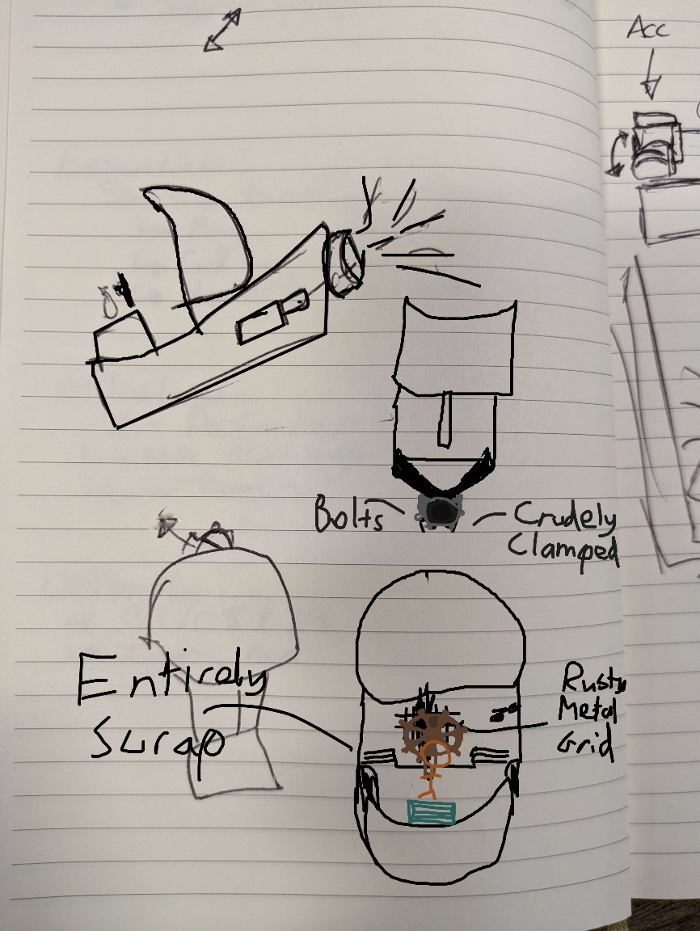

I thought about how the player would gather items and landed on a **massive hoover** on the front of the ship to *suck up* any asteroids small enough to fit inside the hoover.

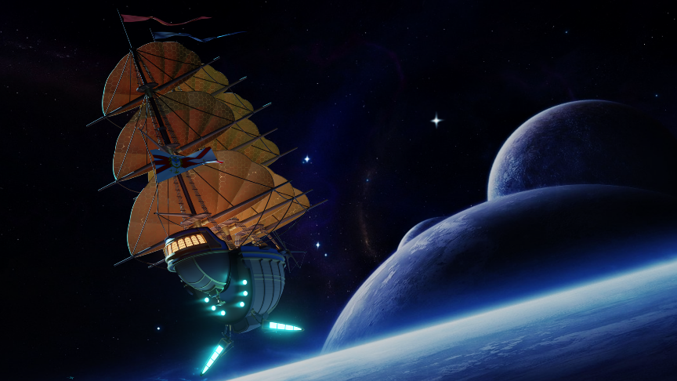These asteroids the player must collect could be fruit based with the player hoovering them up which led to the idea of then squashing them down under intense pressure / heat to make oil.

*Propelled by emissive thrusters from the back. Similar to this: ->*

*But much more rustic / scrappy*

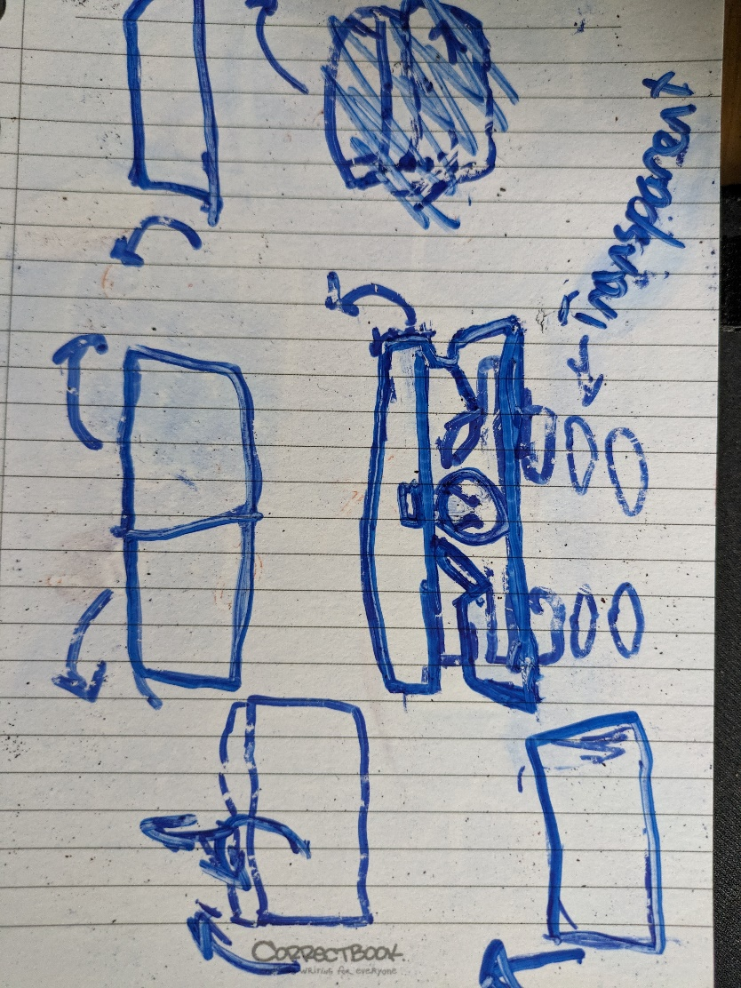

## Open / Closable Box

Starting off straight away with some first sketches I pictured this floating crate with a huge emblem on the front. I took inspiration from Job simulator with an added more sci-fi flare.

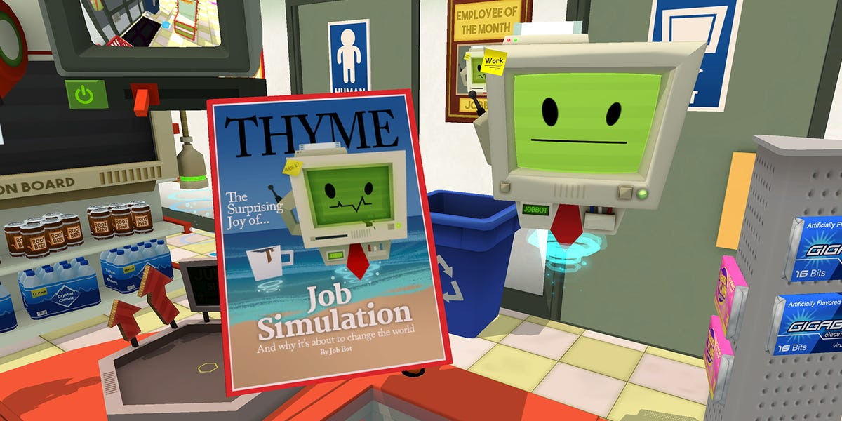

This inset into the box will serve as a massive emissive strip that follows around the side of the box lighting up the surrounding close objects. When designing I tried to think of creating the perception of smooth edges and curves while still keeping low amount of polygons.

Each polygon should be stretched in some unique way to add more characteristics to the box while keeping under 1000 limit.

### Interactivity - Lid / Opening mechanism

Sticking to the sci-fi theme my first idea was to have a rolling shutter on the crate’s lid that, when the player walked up to, would open, with a small sound effect, sideways to reveal its contents such as below.

However, as I planned for the player to be able to access everything from moving physically, I have to place items very close to one another potentially causing false triggering.

I experimented with a plethora of ideas looking at other VR games chests and physical interactions with the handles of the lid is much more gratifying than watching any animations.

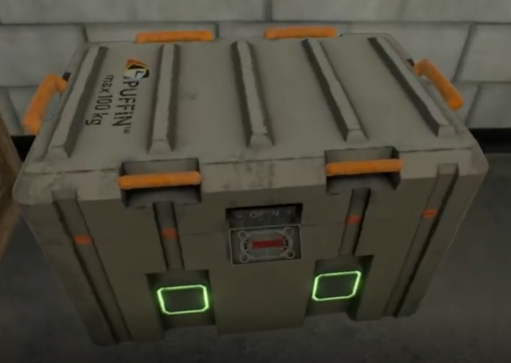

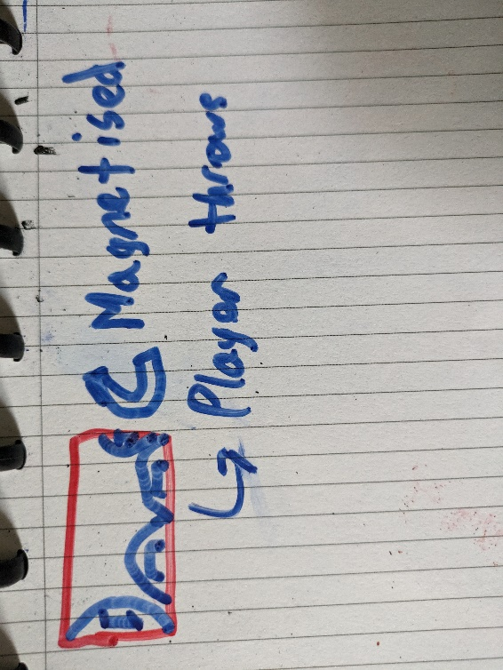Taking inspiration from the popular game Boneworks, I draw up some plans to make an arched lid with these grips on the side the player would use to pickup and throw the lid away.

Since the environment is zero gravity it’s plausible for the lid to be electro magnetised back toward the hinge.

### Materials

* Aluminium - interior
* Zinc - Handles
* LED strip
* Heavily Worn Steel – exterior
* Bronze emblem

## Fruit

Fruit is a tricky one. Given the theme and environment I’ve chosen, normal fruit doesn’t make sense. I had a few options in mind ranging from alien fruit to computer fruit parts (silicon chips).

The idea I envisioned was a series of asteroids similar to the space junk galaxy from Mario galaxy, shaping them to be huge stoney asteroids shaped as common fruits people know such as:

Apples, Banana, Strawberries, Mango, Pineapple

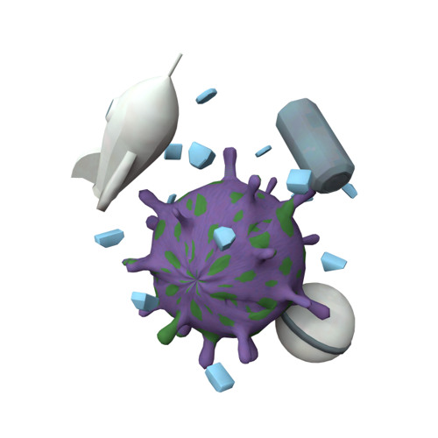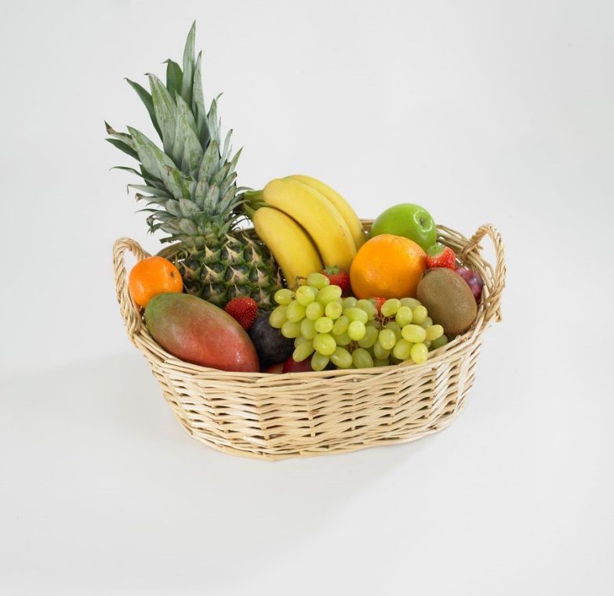The idea would be to experiment with Maya to find some way to create small bumps on the model quickly allowing me to create a variety of basic low-poly fruits.

### Interactivity

The fruits will be the main interaction of the game with the player flying around space sucking up smaller asteroids for resources into their ship.

This also gives me the opportunity to add a loadable cannon on the ship that can be used to break down some of the bigger asteroids into smaller chunks to be absorbed by the ship.

## Materials

* Rock
* Different Ores

## Drink Vessel - TODO

# Planning Controls

The controls need to be **intuitive** for anyone and be **fun** to interact with. Which is the most difficult bit as the player isn’t really touching anything…

## Steering

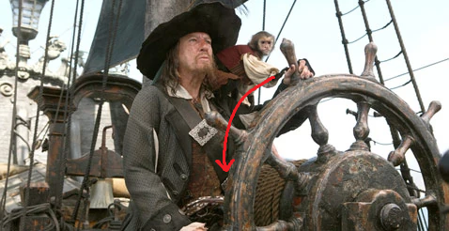

The steering at the helm needs to act as the player would have imagined, working with **one or both hands** and being entirely **physics based**.

By that I mean the player should be able to “**throw**” the steering to the left or right completely letting go of steering wheel and the wheel should continue turning as you see in film / TV.

(For the player to feel *cool* when doing it)

## Acceleration

Controlling speed, I envision the funniest way would be to copy a classic plane accelerator with my direct inspiration being the doctor who time warp lever.

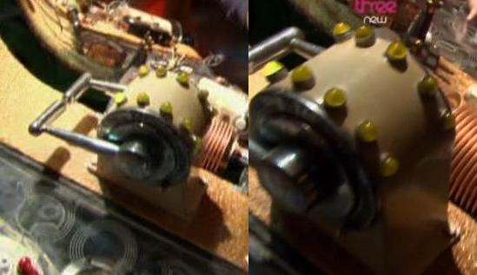

*Reference Doctor Who*

## Up & Down



1. ***Buttons***

Using buttons would be the **easiest** solution to implement but in VR would end up being the most **frustrating.** Having to hold your finger down a button that doesn't physically exist while also not directly looking at your hands (the player would be looking in-front of them) is a recipe for disaster, especially once you factor in tracking loss.

1. ***Rope***

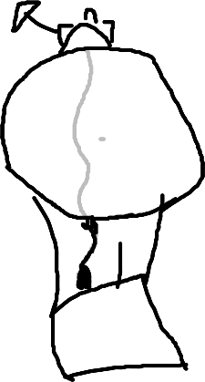This would mimic the functionality of a **hot air balloon**, releasing gas below the ship to allow it to rise slowly. Which has the added benefit of making sense physically, following how spaceships release gas to pivot and dock to space stations.

The downside for this idea is that there are **no great solutions for going down**. Either I:

Place a second rope which could cause confusion.

Have the ship constantly be moving down slightly (via a gravitational force)

Allow the user to *Push* the rope up to go down (doesn’t feel right)

1. 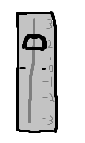***Flat Lever***

An apparatus would be mounted on top of table and would be a lever the player could adjust to the desired speed of elevation. This is the **most** **intuitive** out of all the ideas.

However, it **isn’t fun** to interact with, the player just sets the desired speed directly. Following the scrap pirate ship theme, it feels wrong to interact with this precise instrument.

1. ***Hand Break***

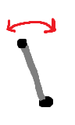Compared all other ideas this would be able to quickly change elevation speed while still having the precise input to be able to gently manoeuvre being an analogue lever. Although being overall **less precise** than flat lever. I feel it’s more appropriate to be found on a scrap ship and more importantly much more **fun** to interact with. (In theory)

## Oil Maker

Once the player has hoovered up any asteroids, they must convert them into oil.

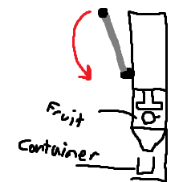

The player would place some asteroid shaped fruit inside then pull down on the lever (reusing the same handbrake system) causing the press to crush the fruit down into oil. The oil would then funnel down to the container allowing the player to drink and continue living.

## Layout

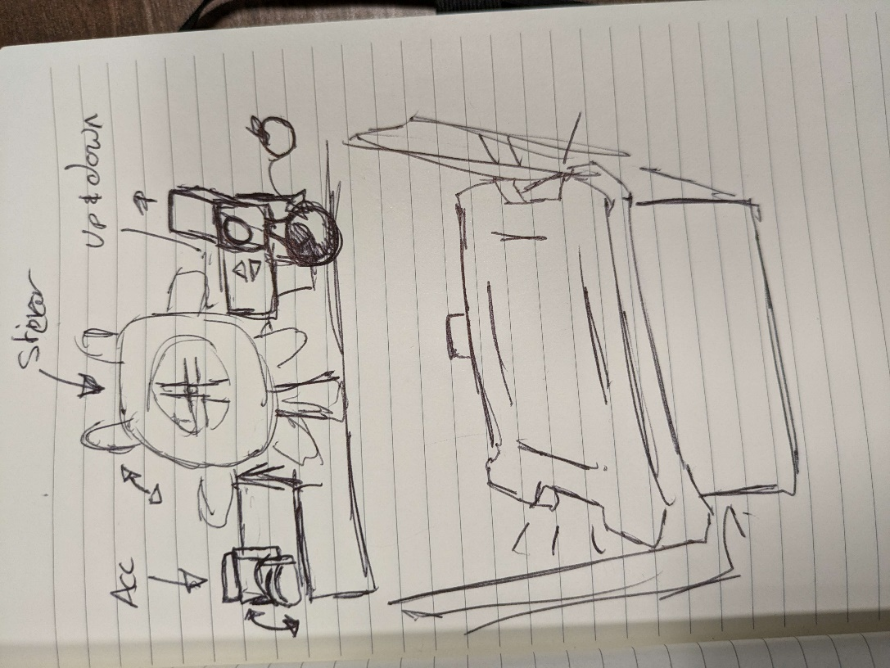

*Thanks Atlas, for sketching much better than me*

# Unity Pre-Work – Might cut

While I was working on some of the environmental design and theming for the game I jumped into unity to understand the scope of what I was attempting to do.

I created a basic pirate environment, with the primitive shapes available by default inside unity.

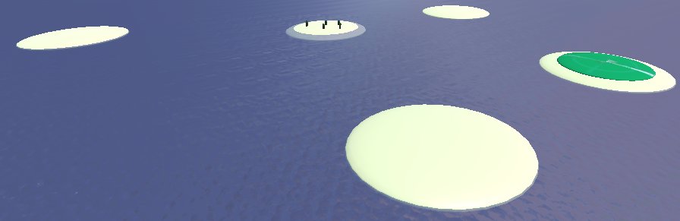

The water is just a plane with a water shader I found on the internet which ended up being scrapped.

<https://assetstore.unity.com/packages/2d/textures-materials/water/simple-water-shader-urp-191449>

*Link to the scrapped water shader.*

# Modelling

## Ship

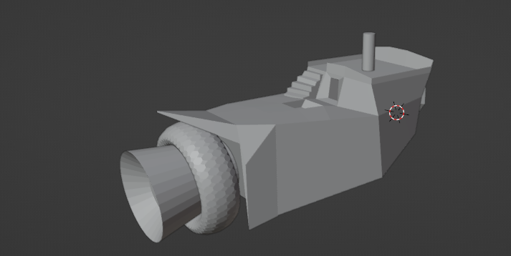

## Open/Closable Box – TO DO

## Fruit – TO DO

### Blender Deform

## Drink Vessel - TODO